Here are a few problems I would like you to fix

1-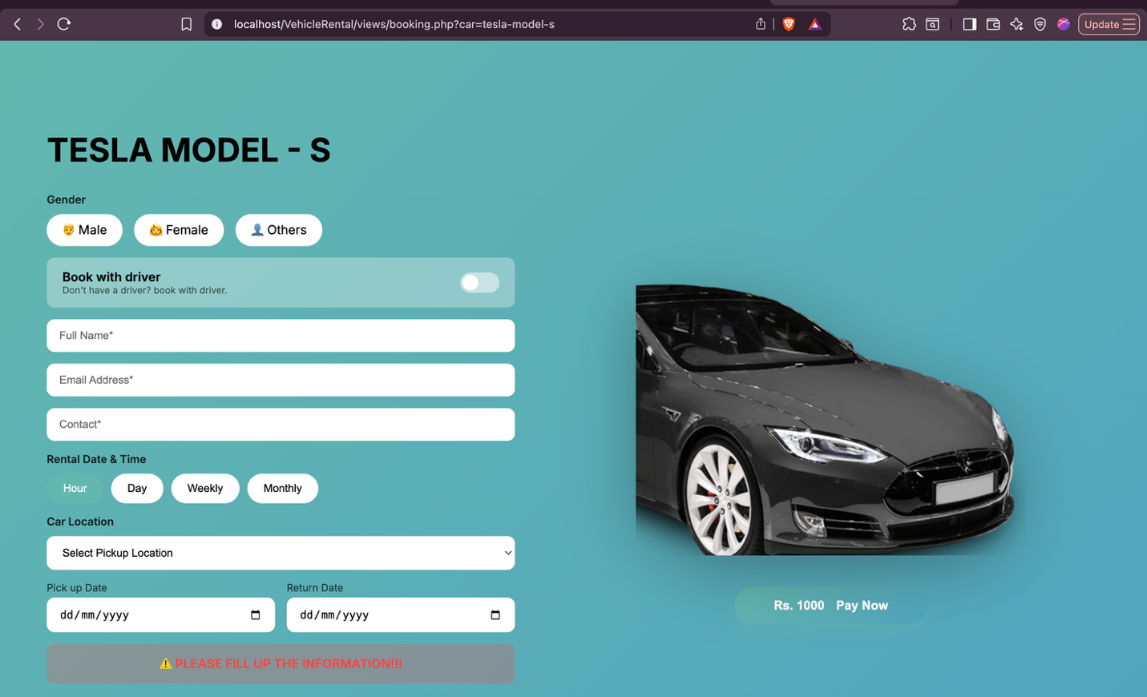

Here make this male female button working . it doesn’t work now
Make this fill uo the form text pop onlyt whem the user triess to press book without enntering proper details .
Remove book w a driver button

Make that hour day weekly monthly button properly working 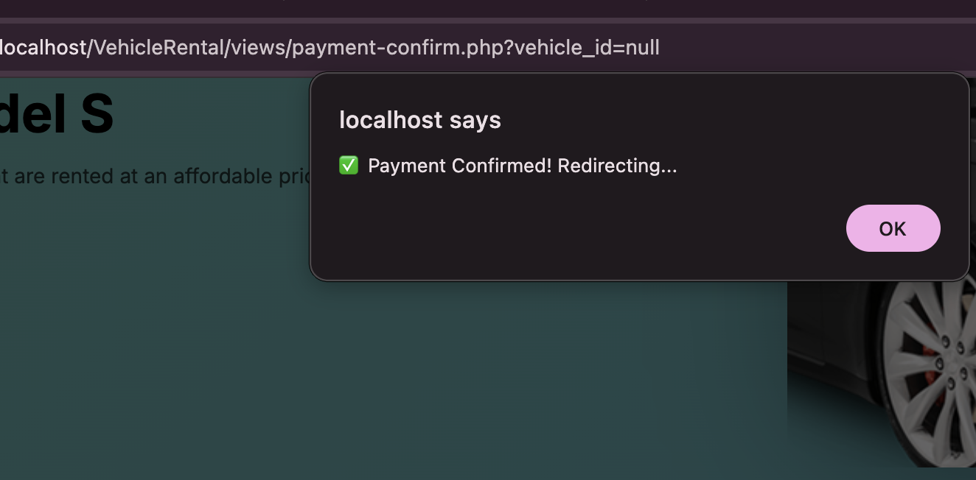
After I confirm payment it says this and when I press okay it goes to this

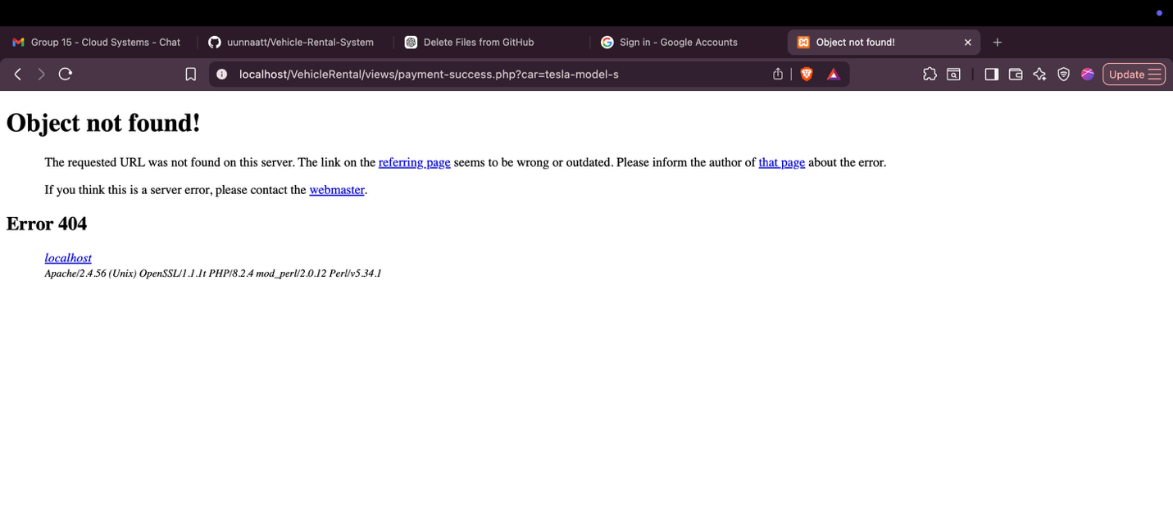

Fix this
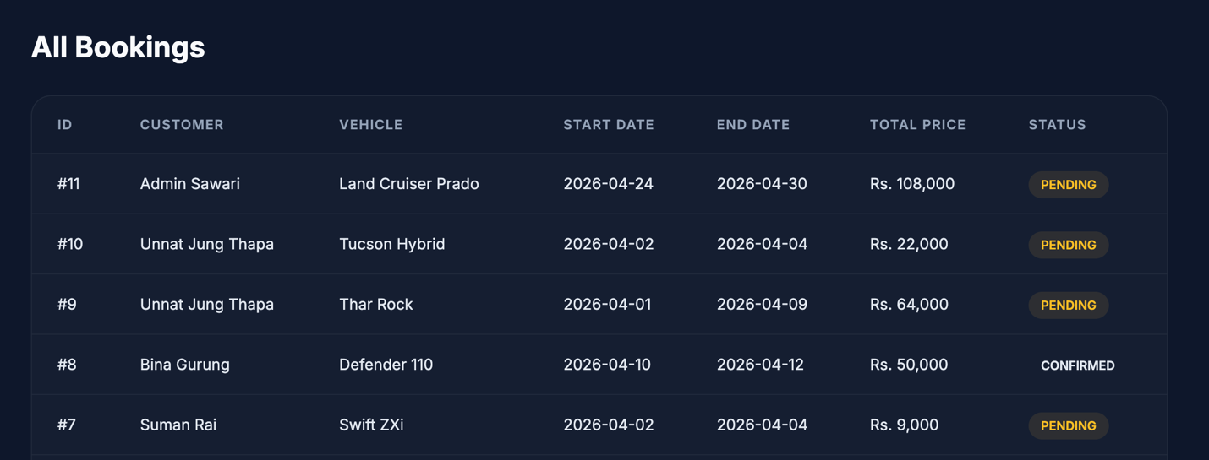

In admin dashboard I need yto be able to change the status of the vehicle cause I cant do it rn .

And I have noticed there isnt proper authentication for iuser and admin login . add csrf token to authenticate it

